Laxmi Charitable Trust’s
Sheth L.U.J College of Arts & Sir M.V. College of Science and Commerce
Department of Information Technology (Bsc.IT Semester III)
Data Structures Practical

Practical - VIII
Roll No. : S010 | Name: ANJALI GUPTA
Class : SYIT | Batch : 1
Date of Assignment : 12/08/2026 | Date/Time of Submission : 12/08/2026

Sorting Algorithms:
Write programs to implement and compare the following sorting algorithms:
- Bubble sort
CODE:
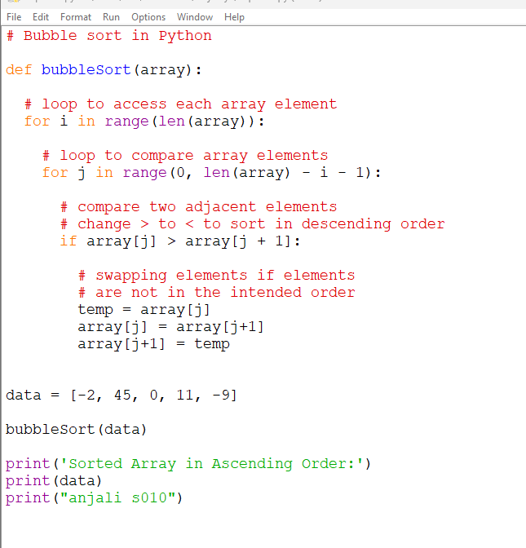
OUTPUT:
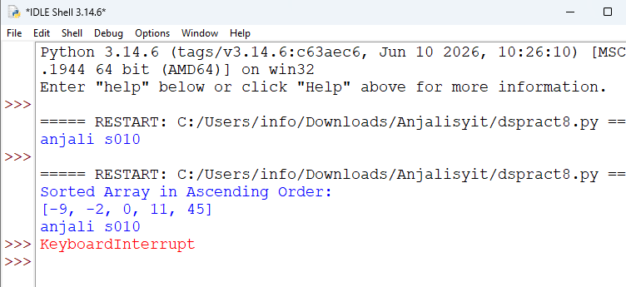

- Selection sort
CODE:
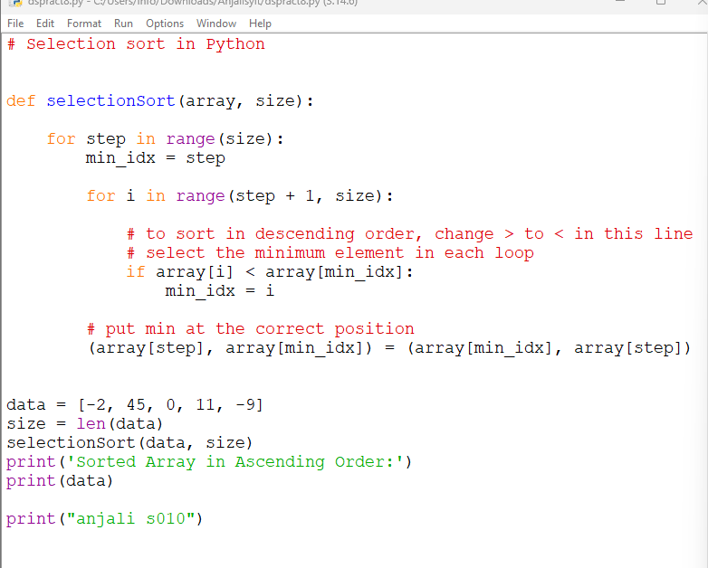
OUTPUT:
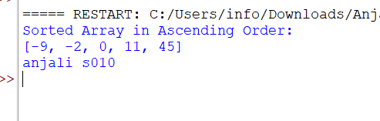

- Insertion sort
CODE:
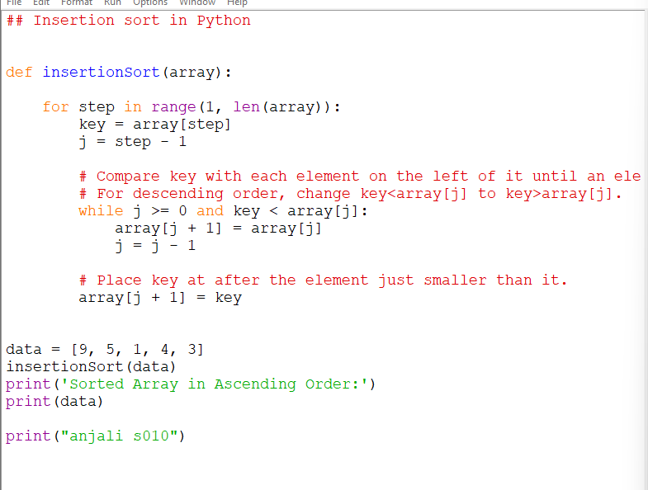
OUTPUT:
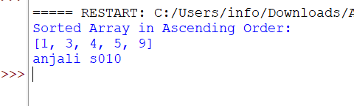
compare the bubble sort,selection sort,insertion sort 